Team Name:

D.A.Y

Team Members:

Adrian Poh Eik Yong

Daniel Fok Chun Hoe

Lee Yi Yang

**BIG**

a. Summary, Situational Analysis and Key issues

Analyse the given problem statement, including a situational analysis and key issues your team is targeting.

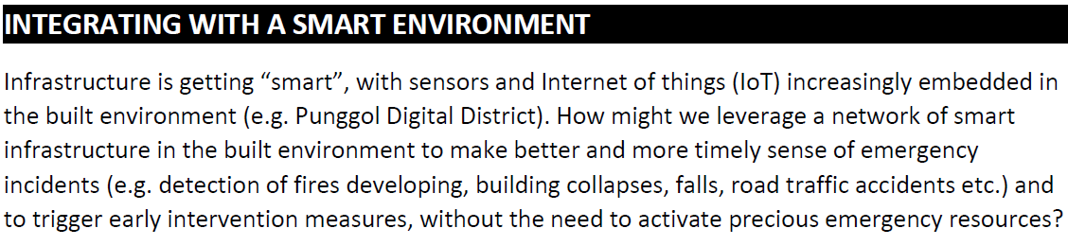

Problem Statement Analysis:

The problem statement is requesting for a solution that focuses on early detection for early intervention in order to minimize instances of emergencies that require emergency resources.

Situational Analysis:

One prevalent problem about big data is the inability of organizations to cope with the vast variety of data that is coming in from the multitude of IOT devices. That also means that it may be difficult to gain insights when data is cluttered all over the place.

Key Issues:

Our team will be targeting the problem of big data aggregation to facilitate the process of analysis.

b. Strategy and Recommendations

Clear explanation of the justification and direct impact of the solution, including how coding and IBM Cloud is used in the solution.

Solution:

Data platform that consumes all IOT device data streams and aggregates them into standardized formats that allow for easy retrieval for analysis.

Impact:

All machine learning models can be hooked up to the platform instead of collecting data from individual sources. This expands the breadth of data available to machine learning algorithms to generate insights.

Programming:

IOT devices will be modelled as objects with an accompanying identification, data_class and data_base.

E.g. IOT_Device('Punggol Blk 71 Chute A', ‘temperature’, data_base)

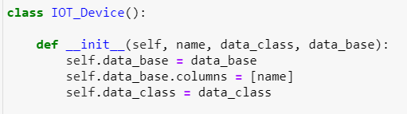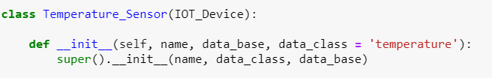

The data platform (called DMAG, or Data Mega Aggregator) will continually take in IOT_Device inputs and store their data_bases after aggregation.

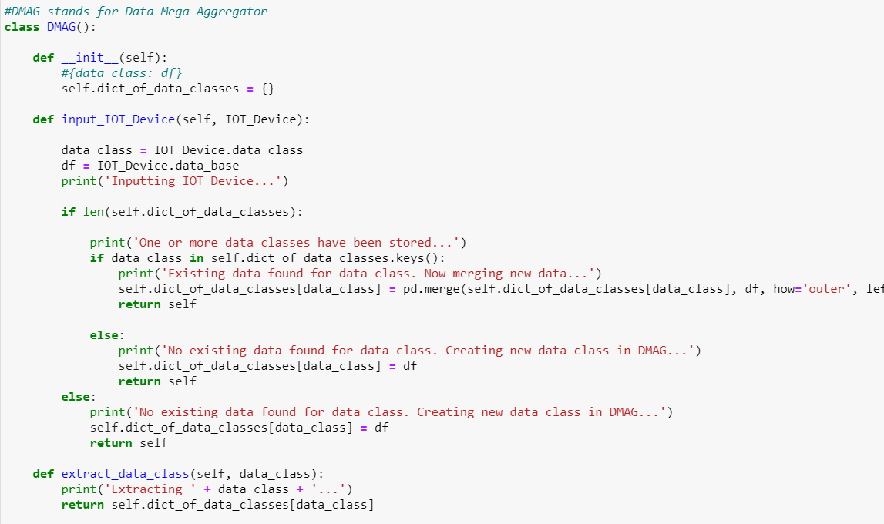

SCDF can create their own models to analyze data from DMAG.

The standard model class will extract whatever databases it requires from DMAG and have its own algorithms in place to conduct the analysis.

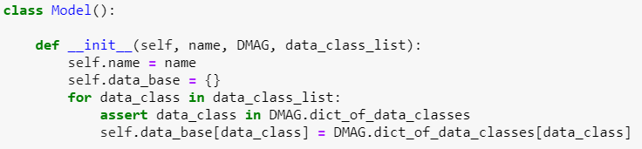

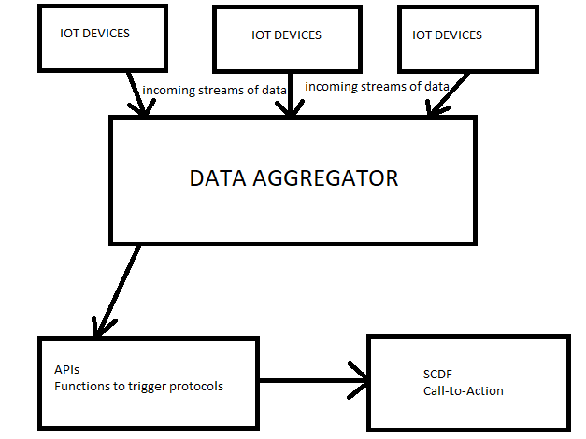

We will go through one simple example of how models can be integrated with the DMAG in the next page.

**Rubbish Chute Fires**

Temperature sensors can be installed in rubbish chutes to detect ambient temperature in the rubbish chutes. Here is an example of a temperature sensor object modelled for a rubbish chute in Punggol.

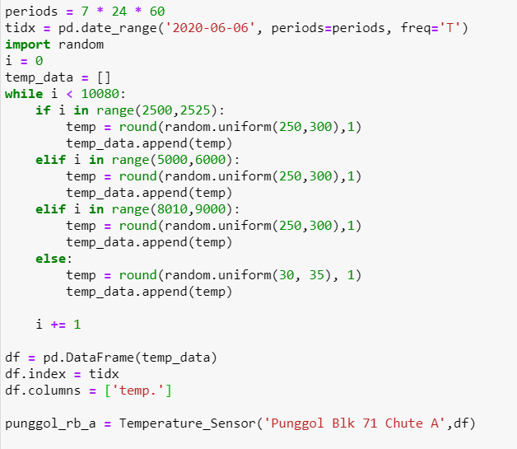

SCDF can create its own Rubbish Chute Fire model with its required parameters. Our rubbish chute fire model also requires that emergency automatic extinguishers are installed in rubbish chutes to douse fires. We have made one with simple rules:

1. If temperature is 2 standard deviations above the rolling 1-day mean, a fire is detected. Emergency automatic extinguishers are deployed.
2. If a fire has been detected for 5 consecutive minutes, Fire Measure 2 is activated.
   * Town council cleaners or participating members of the public are notified to assist in putting out the fire.
3. If a fire has been detected for 15 consecutive minutes, Fire Measure 3 is activated.
   * SCDF is immediately notified to activate resources.

Machine learning algorithms can be implemented with IBM’s AutoAI to predict when the measures will be required to be implemented.

An example of the model is shown below:

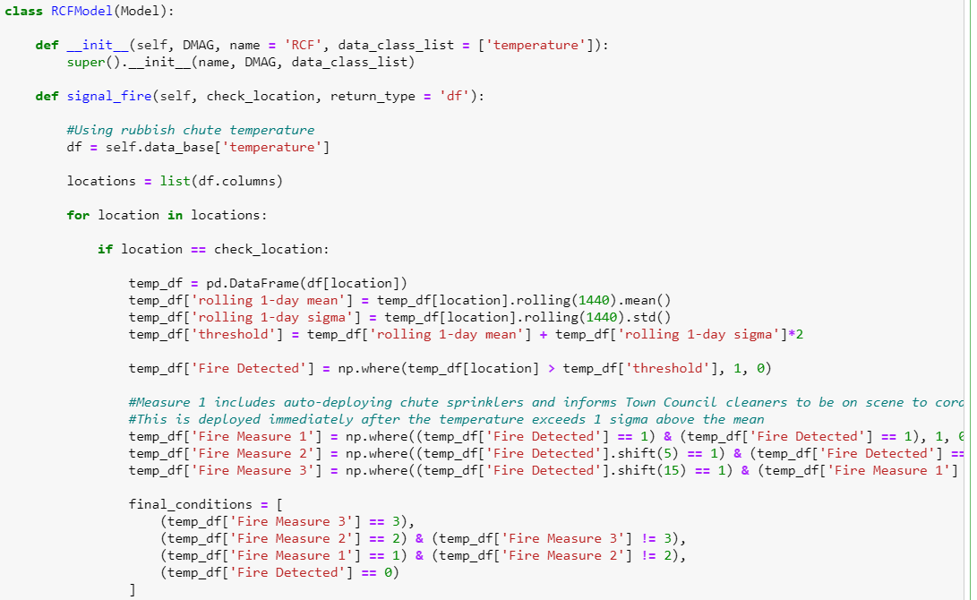

Model can have adjustable return types such as:

1. Historical dataframe
   * 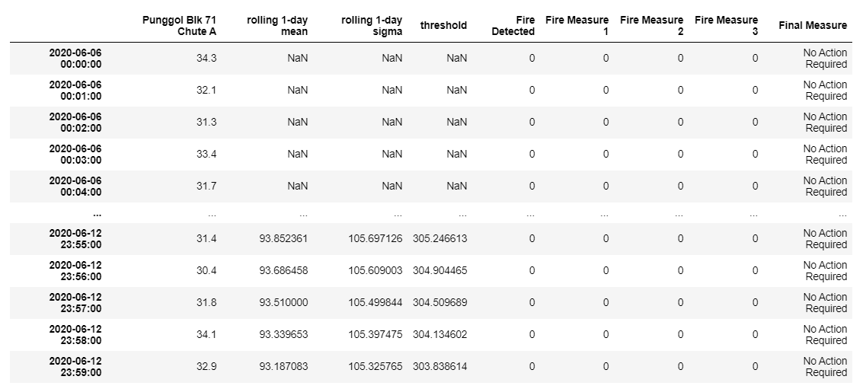

1. Messages (These are what will be sent to SCDF)
   * 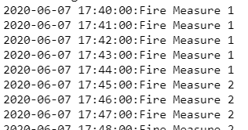
2. Chart
   * 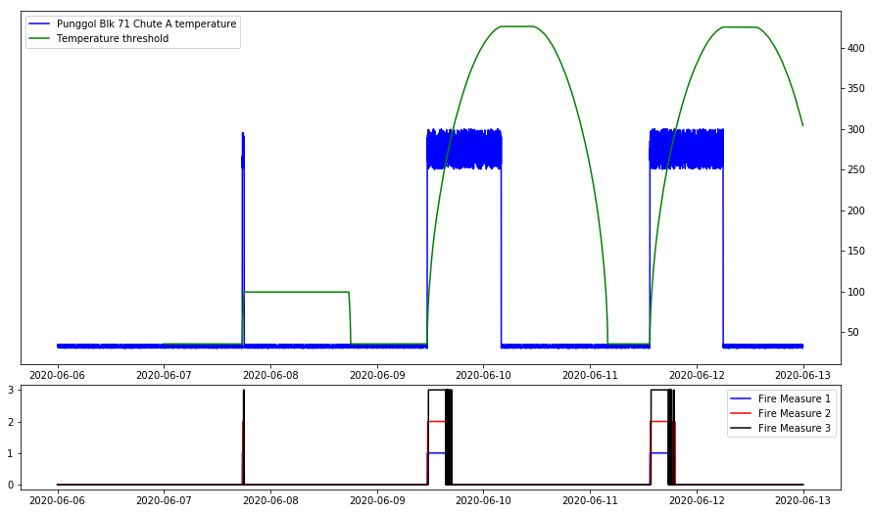

c. Implementation and Plan of Action

Explain how your team will feasibly implement the solution, including possible challenges and mitigation strategies.

Implementation:

SCDF (or Singapore Department of Statistics) must collaborate with all relevant organizations to set up a live data feed from all IOT Devices to DMAG.

SCDF (or any other organizations that desire to have a protocol that benefits from DMAG’s live database) will programme their own APIs that use the data from DMAG.

A link must be set up between the DMAG and model, both of which should be housed on cloud infrastructure e.g. IBM Cloud.

Challenges and mitigations:

1. Not all organizations may be willing to share their data streams. However, with the right checks and balances and restrictions on what data can be shared (as long as it is considered essential for emergency services).
2. Organizations may be reluctant to participate since they can implement such measures themselves, including automatic alerts to SCDF. However, some may be persuaded when they see what predictive insights are possible with the larger breadth of data available for machine learning, which will ultimately benefit the community when future emergencies are intervened before happening.
3. Not all organizations may have the internet capability to provide live data streaming. This is not too big of an issue as long as the gap between data points is not too big e.g. > 10

d. Conclusion

Final summary of how your solution directly responds to the problem statement.

By aggregating big data from across the entire island, increasingly complex and comprehensive models can be built to model the activity happening in the country.

With reference to our example of the Rubbish Chute Fire model:

The solution will be able to trigger early intervention measures as it is able to detect an fire outbreak much earlier than members of the public, leading to faster responses to outbreaks or even the outright prevention of one happening.

This removes the need from the SCDF to activate unnecessary emergency resources in minor cases and increase the efficiency in only deploying what is absolutely necessary.